**[Title of the article in the main language (Spanish or English) with a length of no more than 14 words, with font size 18, bold typeface and Times New Roman].**

*Translated title*

[1]Author's name, educational level, institutional affiliation, e-mail, Orcid code and updated CvLac link.

[2] Author's name, educational level, institutional affiliation, e-mail, Orcid code and updated CvLac link.

[3] Author's name, educational level, institutional affiliation, e-mail, Orcid code and updated CvLac link.

# **Summary**

The form requested for papers is based in part on the formats used for IEEE papers. The abstract should not exceed 150 words and should state what was done, how it was done, the main results and their significance. Do not cite references in the abstract, nor delete the space above the abstract. Leave two blank spaces after the ABSTRACT to start with the text of the article.

***Keywords:*** We suggest no more than four words or short phrases in alphabetical order, separated by commas, that represent your report.

**ABSTRACT**

Abstract translated into English or Spanish if the original language is in a different language.

***Keywords: Keywords*** translated into English or Spanish if the original language is in a different language.

# **introduction**

The introduction section corresponds to the presentation of the problem that motivates the study carried out, where a clear context is delimited that will allow the reader to understand the variables or factors that affect the phenomenon or issue addressed, and which, in addition, support the need for the study proposed in the manuscript. Likewise, this section should present the different components that the reader will find in the reading of the chapter.

# **theoretical framework or frame of reference**

The theoretical framework section -or referential framework, as appropriate- should present those theoretical or conceptual elements that support the research presented in the article. Therefore, it will be of utmost importance to provide sufficient clarity to give a clear theoretical overview, which in turn will allow a better understanding of the following sections of the manuscript.

For the development of the document we indicate the following suggestions.

# Helpful hints

## Figures and tables

Because IEEE will format your document last, large figures and tables may take up space in both columns. Place figure captions below figures; place table captions above tables. If your figure has two parts, include the labels "(a)" and "(b)" as part of the artwork. Please verify that the figures and tables you mention in the text actually exist. **Please do not include captions as part of the figures. Do not put captions in "text boxes" linked to figures. Do not put external borders on your figures.** Use the abbreviation "Fig." even at the beginning of a sentence. Do not abbreviate "Table." Tables are numbered with Roman numerals.

**Do not use color unless it is necessary for proper interpretation of your figures.** Figure axis labels are often a source of confusion. Use words instead of symbols.

TABLE I

Units for Magnetic Properties

|  |  |  |
| --- | --- | --- |
| Symbol | Quantity | Conversion from Gaussian and  CGS EMU to SI a |
| Φ | magnetic flux | 1 Mx→ 10−8 Wb = 10−8 V-s |
| *B* | magnetic flux density,  magnetic induction | 1 G→ 10−4 T = 10−4 Wb/m2 |
| *H* | magnetic field strength | 1 Oe→ 103 /(4π ) A/m |
| *m* | magnetic moment | 1 erg/G = 1 emu  → 10−3 A-m2 = 10−3 J/T |
| *M* | magnetization | 1 erg/(G-cm3 ) = 1 emu/cm3  → 103 A/m |
| 4 Mπ | magnetization | 1 G→ 103 /(4π ) A/m |
| σ | specific magnetization | 1 erg/(G-g) = 1 emu/g→ 1 A-m /kg2 |
| *j* | magnetic dipole  moment | 1 erg/G = 1 emu  → 4 π× 10−10 Wb-m |
| *J* | magnetic polarization | 1 erg/(G-cm3 ) = 1 emu/cm3  → 4 π× 10−4 T |
| χ, κ | susceptibility | 1→ 4π |
| χρ | mass susceptibility | 1 cm /g3→ 4 π× 10−3 m /kg3 |
| μ | permeability | 1→ 4 π× 10−7 H/m  = 4 π× 10−7 Wb/(A-m) |
| μr | relative permeability | μ→ μr |
| *w, W* | energy density | 1 erg/cm 3→ 10−1 J/m3 |
| *N, D* | demagnetizing factor | 1→ 1/(4 )π |

No vertical lines in table. Statements that serve as captions for the entire table do not need footnote letters.

aGaussian units are the same as cgs emu for magnetostatics; Mx = maxwell, G = gauss, Oe = oersted; Wb = weber, V = volt, s = second, T = tesla, m = meter, A = ampere, J = joule, kg = kilogram, H = henry.

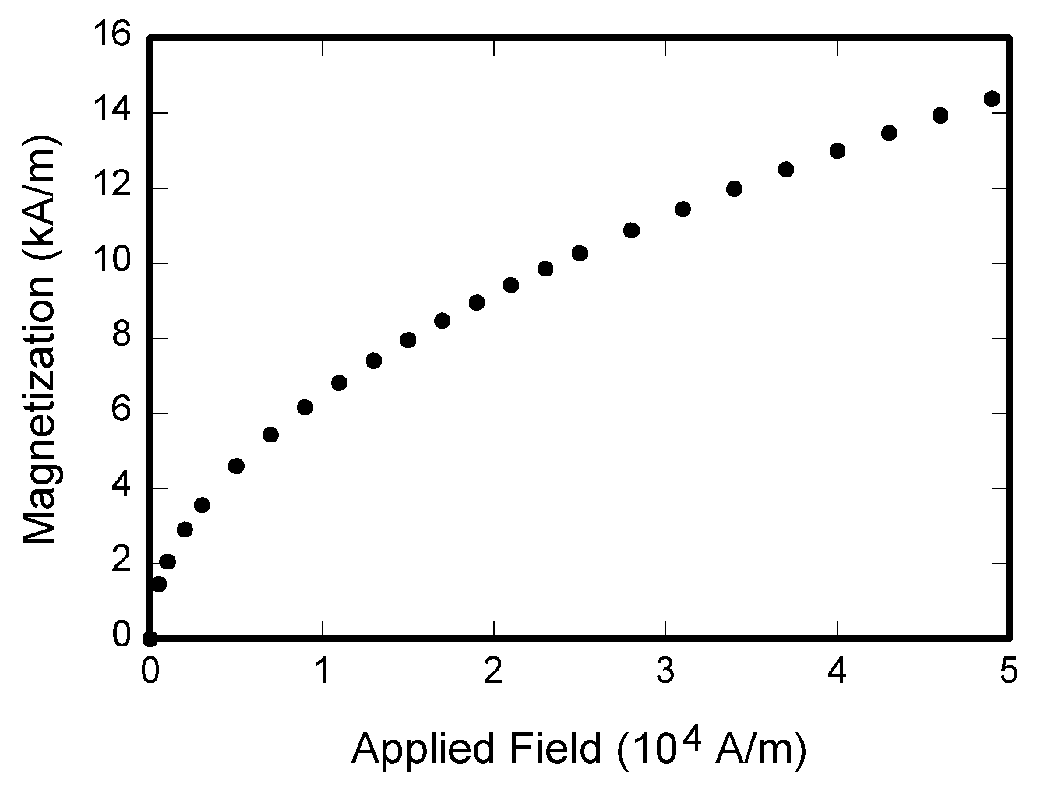

Fig. 1. Magnetization function. Note that "Fig." Is abbreviated. There is a space after the figure number, followed by two spaces. It is good practice to explain the importance of the figure in the subtitle.

## References

Within the text, number the citations in square brackets [1], following the order in which they appear related in the last section of the article, called REFERENCES. The period of the sentence follows the parentheses [2]. Multiple references [2], [3] are numbered with separate parentheses [1]-[3]. When citing a section in a book, please give the relevant page numbers [2]. In sentences, simply refer to the reference number, as in [3]. Do not use "Ref. [3]" or "reference [3]" except at the beginning of a sentence: "the Reference [3] shows...."

Number footnotes separately in the exponents (Insert | Reference | Footnote). Put the actual footnote at the end (bottom) of the column in which it is cited; do not put footnotes in the reference list (endnotes). Use letters for footnotes in the table (see Table I).

Please note that the references at the end of this document are in preferred referencing style. **There they are arranged in alphabetical order of the author's last name**. Give all authors' names; do not use "et al" unless there are six or more authors. Avoid using the initials of authors' names. Spell out surnames and first names whenever possible. Papers that have not been published should be cited as "unpublished" [4]. Papers that have been submitted or accepted for publication should be cited as "submitted for publication" [4]. Please give affiliations and addresses for personal communications [6].

## Abbreviations and Acronyms

Define abbreviations and acronyms the first time they are used in the text, even after they have been defined in the theory. Abbreviations such as ACM, IEEE, SI, ac, and dc do not have to be defined. Abbreviations with embedded periods should not have spaces: write "C.N.R.S.," not "C. N. R. S." *Do not use abbreviations in the title* unless they are unavoidable (e.g., "IEEE" in the title of this article).

## Equations

Number the equations consecutively with the equation numbers in parentheses against the right margin, as in (1). First use the equation editor to create the equation. Then select "Equation" style. Press the tab key and type the equation number in the parentheses. To make your equations more compact, you can use (/), the exp function, or appropriate exponents. Use parentheses to avoid ambiguities in the denominators. Punctuate the equations when they are part of a sentence, as in

 (1)

Make sure that the symbols in your equation have been defined before or immediately after the equation appears. Italicize the symbols (*T* could refer to temperature, but T is the tesla unit). Refer to "(1)," not "Eq. (1)" or "equation (1)," except at the beginning of a sentence: "Equation (1) is...."

# **method or methodology**

The chapter's methodological route presents in detail the steps followed by the author to achieve the stated objective, and should therefore answer questions such as: i) the focus of the study; ii) scope of the research (descriptive, exploratory, explanatory or correlational); iii) data collection techniques; iv) data analysis techniques; and v) inclusion and exclusion criteria (depending on the type of study).

# **CONCLUSION**

A conclusion section is not necessary. However, it can review the main points of the article, do not repeat the abstract as a conclusion. A conclusion is drawn based on the importance of the work done or on suggested applications and extensions.

# **References**

1. G. O. Young, "Synthetic structure of industrial plastics (Book style with paper title and editor)," in *Plastics*, 2nd ed. vol. 3, J. Peters, Ed. New York: McGraw-Hill, 1964, pp. 15-64.
2. W.-K. Chen, *Linear Networks and Systems* (Book style)*.* Belmont, CA: Wadsworth, 1993, pp. 123-135.
3. H. Poor, *An Introduction to Signal Detection and Estimation*. New York: Springer-Verlag, 1985, ch. 4.
4. B. Smith, "An approach to graphs of linear forms (Unpublished work style)," unpublished.
5. E. H. Miller, "A note on reflector arrays (Periodical style-Accepted for publication)," *IEEE Trans. Antennas Propagat.* to be published.
6. J. Wang, "Fundamentals of erbium-doped fiber amplifiers arrays (Periodical style-Submitted for publication)," *IEEE J. Quantum Electron.* submitted for publication.
7. C. J. Kaufman, Rocky Mountain Research Lab, Boulder, CO, private communication, May 1995.
8. Y. Yorozu, M. Hirano, K. Oka, and Y. Tagawa, "Electron spectroscopy studies on magneto-optical media and plastic substrate interfaces(Translation Journals style)," *IEEE Transl. J. Magn.Jpn.*, vol. 2, Aug. 1987, pp. 740-741 [*Dig. 9th Annu. Conf. Magnetics* Japan, 1982, p. 301].
9. M. Young, *The Techincal Writers Handbook.* Mill Valley, CA: University Science, 1989.
10. J. U. Duncombe, "Infrared navigation-Part I: An assessment of feasibility (Periodical style)," *IEEE Trans. Electron Devices*, vol. ED-11, pp. 34-39, Jan. 1959.

1.
2.
3.