Editorial Policy

Pensamiento Americano Journal

Content

**1. Introduction** 3

**2. Approach and Scope** 3

**Types of Manuscripts** 3

**4. Peer Review Process** 4

**5. Evaluation Criteria** 5

**6. Guidelines for Manuscript Submission** 5

**6.1. Editorial flowchart of the journal** 6

**6.2. Publication process and responsible parties** 8

**7. Open Access Policy** 9

**7.1. Introduction** 9

**7.2. Open Access: Definition and Models** 10

**7.3. Implementation of Golden Open Access in American Thought** 10

**7.4.** **Cost Coverage** 11

**8.1. Long-Term Preservation: Why is it Important?** 12

**8.2. Data Management Plan for Content Preservation** 12

**Metadata and Documentation** 13

**8.4. Format Updating and Migration** 13

**8.5** **Reliable Repositories for Long-term Preservation** 13

**Ethics and Best Practices** 14

**9.1. Ethics policy** 14

**10. Editor's Responsibilities** 17

**11. Responsibilities of the Peer Reviewers** 18

**12. Author's Responsibilities** 18

**13. Responsibilities of Pensamiento Americano Journal** 18

**14. Article Publications for Special Issues** 18

**15. Estimated Time of Publication** 19

**16. Manuscript Submission** 19

### **1. Introduction**

Pensamiento Americano is a scientific journal identified with ISSN: 2027-2448 and ISSN-e: 2745-1402, dedicated to the publication of research, review and reflection articles in the area of social sciences, humanities and education. Our goal is to foster academic exchange and contribute to the advancement of knowledge in these disciplines. The journal accepts manuscripts in Spanish, English and Portuguese.

### **2. Approach and Scope**

The journal focuses on the dissemination of research and essays that address contemporary, historical, theoretical and methodological problems in the Social Sciences, such as: Law, Anthropology, History, Sociology, Philosophy, Psychology, Cultural Studies, Political Science, Pedagogy, Social Work, etc. Pensamiento Americano publishes works that offer new perspectives and contribute to the academic debate and to the solution of social and educational problems.

### **Types of Manuscripts**

The journal accepts the following types of manuscripts:

* **Research Articles**: Original studies presenting results of empirical or theoretical research.
* **Review Articles**: Critical and synthetic analysis of the existing literature on a specific topic.
* **Reflection Articles**: Essays that offer new and original perspectives on relevant topics in the areas of social sciences, humanities and education.
* **Book review:** Literary criticism in which a book is described or analyzed in terms of its content, style and/or merit.

### **4. Peer Review Process**

All manuscripts submitted to American Thought undergo a rigorous peer review process, which includes the following stages:

1. **Initial Review**: The editorial team performs an initial evaluation of the manuscript to ensure that it meets the formal and thematic requirements of the journal.
2. **Peer Review**: Manuscripts that pass the initial review are sent to external reviewers, experts in the subject matter of the paper. This process is double-blind, i.e., the authors and reviewers do not know each other's identities.
3. **Editorial Decision**: Based on the reviewers' comments, the editorial team makes a decision on the acceptance, revision or rejection of the manuscript. Possible decisions include:
   * Approved without modifications.
   * Approved with structural modifications.
   * Approved with basic modifications.
   * Rejection.

### **5. Evaluation Criteria**

Manuscripts are evaluated according to the following criteria:

* **Relevance and originality**: The work must address a relevant and novel topic in its area of study.
* **Methodological quality**: In the case of research articles, the soundness of the research design and execution is evaluated.
* **Clarity and coherence**: The manuscript should be well structured, with clear and well-supported arguments.
* **Contribution to the field**: The contribution of the work to existing knowledge and its potential impact on the discipline is considered.

### **6. Guidelines for Manuscript Submission**

Authors should follow the following guidelines when preparing their manuscripts:

* **Format**: Manuscripts should be submitted using the journal's template in Word format, with a maximum of 25 pages for research and reflection articles, and a maximum of 25 pages for review articles, excluding references. The length of the reviews should not exceed two pages and their language should be subject to scientific rigor.
* **Style**: Use APA style (latest edition) for citations and references.
* **Structure**: Include an abstract of 150-250 words in the language of the article and in English, followed by keywords (maximum 6). For research articles, structure the manuscript in sections such as Introduction, Method, Results, Discussion and Conclusions.
* **Tables and Figures**: They should be clear and numbered consecutively. Legends should be detailed to allow understanding without the need to refer to the main text.

### **6.1. Editorial flowchart of the journal**

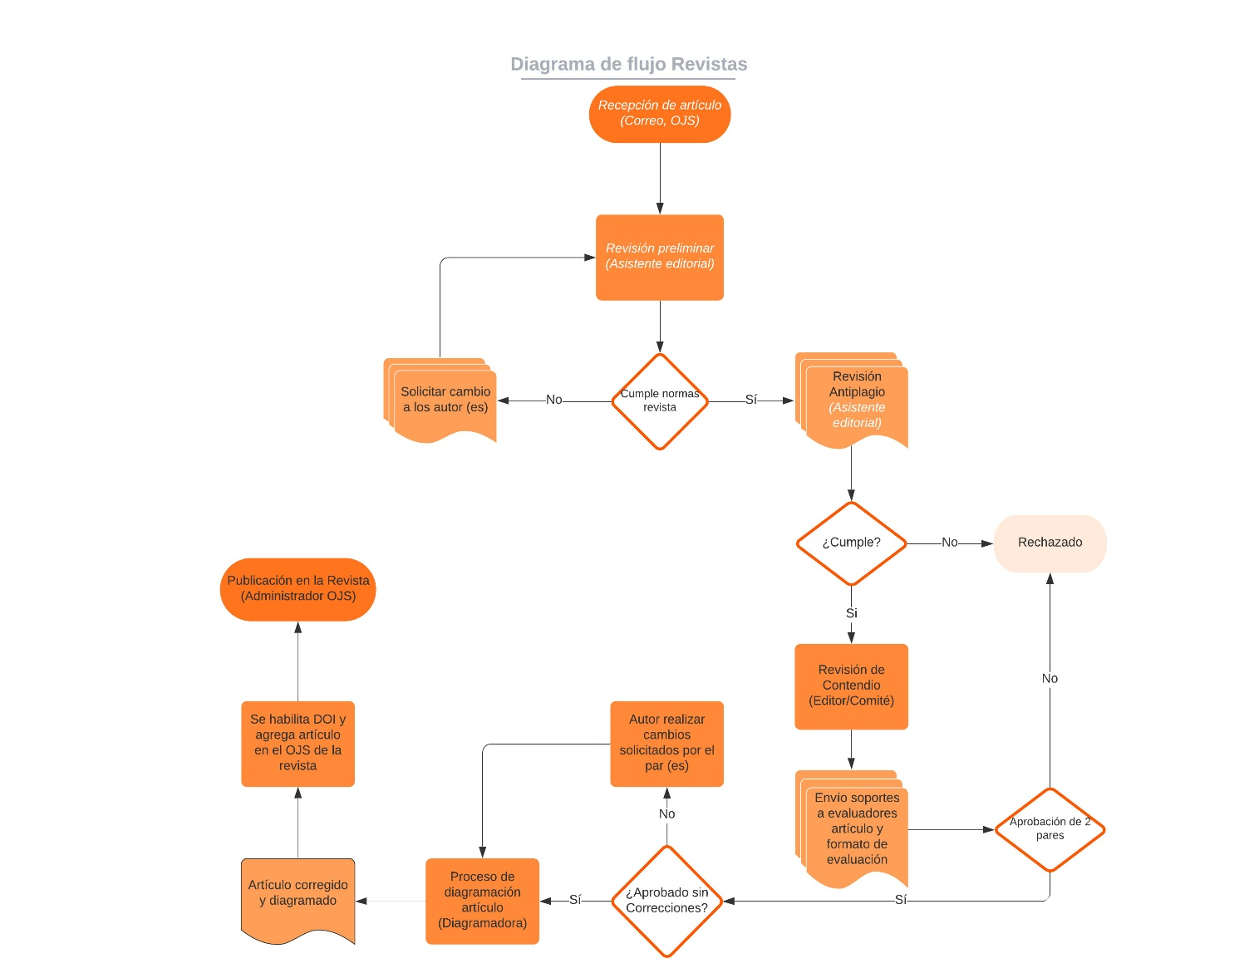

### **6.2. Publication process and responsible parties**

| **N°** | **Activity** | **Description** | **Responsible(s)** | **Registration(s)** |
| --- | --- | --- | --- | --- |
| 1. 1 | Receipt of items | There are two calls for papers per year. However, the reception of articles is open throughout the year.  The author must submit the article through the Open Journal System of the corresponding journal. | OJS Administrator/Editorial Assistant | Author registration in OJS |
| 1. 2 | Review of compliance with criteria | Verify if the postulation of the article complies with the requirements:   * Application through OJS * Article submitted under the respective template * Completed documentation | OJS Administrator/Editorial Assistant | OJS Registration |
| 1. 3 | Review of similarities | Analysis to determine the percentage of similarities on the manuscript (up to 25%) | Editorial Assistant | Anti-plagiarism software report |
| 1. 4 | Preliminary review of the manuscript | Revision of the article on the corresponding template, complete data of the authors and APA norms. | Editorial Assistant | Notification mail |
| 1. 5 | Peer review management | Each article will be assigned 2 expert peer reviewers (or more, if necessary), who will give their favorable verdict to continue with the process, otherwise, a third peer reviewer will be assigned for review, in case the article is rejected, the author will be informed (double blind peer review). | Editorial Assistant | Evaluation form |
| 1. 6 | Proofreading | The manuscript will be reviewed and corrected for wording, punctuation, congruence and APA norms. | Proofreader | Final version of the article |
| 1. 7 | Article layout | The article is diagrammed for publication | Designer Editorial Label | PDF delivery |
| 1. 8 | Notification to the author | The author is sent the final PDF of his article for corrections. | Editorial Assistant | Notification mail |
| 1. 9 | Final publication of the magazine | The article is published in the OJS (open access) of the respective journal. | OJS Administrator | Reflected publication |

### **7. Open Access Policy**

### **7.1. Introduction**

In the current context of scholarly communication and knowledge dissemination, establishing a policy of open access and content preservation has become essential for scientific journals. Pensamiento Americano, committed to the promotion of knowledge and critical thinking in Latin America and the world, recognizes the importance of adopting these practices to maximize the impact and accessibility of its publications.

The implementation of an open access policy makes articles published in Pensamiento Americano freely available to anyone with access to the Internet. This not only broadens the potential audience, but also facilitates the dissemination and exchange of ideas, fostering a more inclusive and diverse scholarly dialogue. For authors, open access increases the visibility of their work, potentially increasing citations and recognition in their field of study.

In addition, content preservation is crucial to ensure that articles remain accessible for the long term. Through digital preservation strategies, Pensamiento Americano ensures that its valuable content is not lost over time, keeping it available for future generations of researchers and readers. The combination of open access and content preservation not only strengthens the integrity and continuity of the journal, but also contributes to the sustainable development of scientific knowledge.

In summary, by establishing a robust open access and content preservation policy, Pensamiento Americano positions itself as a journal committed to the democratization of knowledge and the promotion of quality research, benefiting both authors and readers and strengthening its role in the global academic community.

### **7.2. Open Access: Definition and Models**

**7.2.1. What is Open Access?**

Open Access (OA) refers to the practice of providing free, immediate and online access to scholarly output, without economic, legal or technical barriers. This allows anyone to read, download, copy, distribute, print, search or link to the full text of research articles, thus favoring wider dissemination and use of scientific knowledge.

### **7.3. Implementation of Golden Open Access in American Thinking**

The journal adopts the Dorado open access model, we do not have APC charges for articles, all articles published in the journal's OJS portal can be accessed and downloaded. We are also indexed in different international open access databases such as: DOAJ, CLASE, REDIB and Dialnet among others.

To ensure that the benefits of open access are realized, the journal American Thought will take the following steps:

* + 1. **Creative Commons Licenses**

All articles will be published under Creative Commons licenses (CC BY-NC-ND), allowing readers to copy, distribute and transmit the work, as long as proper credit is given and it is not used for commercial purposes.

* + 1. **Open Repositories**

Articles will be available on the journal's website and will also be archived in recognized open repositories, such as DOAJ, BIBLAT, CLASE and the institutional repository of the Corporación Universitaria Americana.

* + 1. **No Embargo Periods**

American Thought adopts a Gold Open Access model, ensuring that all articles are immediately accessible to the public without any embargo period.

### **Cost Coverage**

The journal does not charge for the processing of submissions and publication of articles, the Corporación Universitaria Americana, which is the sponsoring institution, assumes all expenses, thus minimizing the economic impact on authors and encouraging greater participation in the journal.

By implementing these strategies, Pensamiento Americano is committed to promoting open access and contributing to the advancement of scientific knowledge, benefiting both the academic community and society at large.

1. **Content preservation**

### **8.1. Long-Term Preservation: Why is it Important?**

The long-term preservation of scholarly content is crucial to ensure that scientific and cultural knowledge remains accessible and usable for future generations. In the case of the journal Pensamiento Americano, the preservation of its articles ensures that the research, ideas and contributions of the authors are not lost over time. In addition, a sound preservation strategy:

1. Maintains Continuity of Knowledge: Allows researchers' work to continue to be relevant and useful in the future.
2. Ensures Integrity and Authenticity: Protects items against loss, degradation and alteration, ensuring that the contents remain intact and reliable.
3. Facilitates Access and Reuse: Ensures that articles are available for future research, review and practical application.

### **8.2. Data Management Plan for Content Preservation**

To ensure the preservation of articles published in Pensamiento Americano, a data management plan is adopted that includes the following strategies:

**8.2.1. Digitization and Standard Formats**

All articles will be kept in standard digital formats (such as PDF) that are widely accepted and recognized for their long-term durability and accessibility.

**8.2.2. Multiple Copies and Locations**

Backups of all items will be created and stored in multiple physical locations and in the cloud to protect against data loss due to technical failures or natural disasters.

### **Metadata and Documentation**

Each article will be accompanied by detailed metadata describing content, authorship, date of publication, and other relevant aspects. This metadata facilitates the search and retrieval of articles over time.

### **8.4. Format Updating and Migration**

A plan will be implemented for the periodic review and updating of file formats to ensure compatibility with future technologies. This includes the migration of files to new formats that are in the process of being implemented (XML), and other alternatives such as E-pub will be sought.

### **8. 5Reliable Repositories for Long Term Preservation**

For long-term preservation, Pensamiento Americano will use reliable and recognized repositories that guarantee the preservation and continuous access to the articles. Some of the selected repositories are:

**8.5.1. LOCKSS**

*Lots of Copies Keep Stuff Safe*. This digital preservation program distributes multiple copies of articles across a network of participating libraries, ensuring the integrity and availability of the content. The journal uses the LOCKSS system to create a distributed archive among participating libraries, allowing these libraries to create permanent archives of the journal for preservation and restoration purposes.

**Corporación Universitaria Americana Institutional Repository**

The institutional repository of the university serves as an additional location for the storage and preservation of the articles, allowing to have another server and site to store the information, offering readers, authors and members of the journal support over time to access the articles.

With these measures, Pensamiento Americano ensures that its academic content remains accessible and preserved for current and future generations, consolidating its role as a lasting and reliable source of scientific and cultural knowledge.

### **Ethics and Best Practices**

The journal follows the guidelines of the Committee on Publication Ethics (COPE) and expects authors to adhere to ethical standards in their research. Plagiarism, duplication of publications and any form of scientific misconduct are prohibited. Authors must declare any conflict of interest and obtain the necessary permissions for the use of copyrighted materials.

### **9.1. Ethics policy**

**9.1.1. Introduction**

Pensamiento Americano Journal identified with ISSN: 2027-2448 and ISSN-e: 2745-1402 is dedicated to the dissemination of high quality research and articles in the areas of Social Sciences, such as: Law, Anthropology, History, Sociology, Philosophy, Psychology, Cultural Studies, Political Science, Pedagogy, Social Work, etc., with a particular focus on issues that affect and reflect the diversity of the Latin American community. This publication is based on the principles of academic rigor, originality and relevance, providing a platform for intellectual dialogue and the exchange of unpublished research.

Given the importance of maintaining the trust of our readers, authors and the scientific community in general, we have developed this ethics policy to guide all activities related to the editorial process. Our commitment is to ensure that all parties involved, including authors, reviewers and editors, act with integrity, transparency and accountability.

This policy is in line with international ethical standards such as COPE (Committee of Publication Ethics) in academic publishing and seeks to promote fair and equitable practices in all aspects of journal management. In relation to authors and taking into account the COPE guidelines, Pensamiento Americano makes it clear that: the decisions of the referees to accept or reject a document for publication should be based on its importance, originality and clarity, without ignoring the validity of the study and its relevance.

**9.1.2. General Principles**

* **Integrity:** All parties involved in the publication process (journal team, committees, reviewers) must act with honesty and transparency.
* **Impartiality:** The selection and evaluation of manuscripts will be based solely on their academic quality and relevance, without discrimination based on race, gender, sexual orientation, religion, nationality or ideology.
* **Confidentiality:** Information about submitted manuscripts will be handled confidentially and will not be disclosed to third parties not directly involved in the editorial process.

**9.1.3. Responsibilities of the Authors**

* **Originality:** Authors must guarantee that their papers are original and have not been previously published or under consideration in another journal.
* **Acknowledgment of Sources:** All sources used must be properly cited and permissions obtained for the use of copyrighted materials.
* **Conflict of Interest:** Authors must disclose any financial or other conflicts of interest that could influence the results or interpretation of their work.
* **Correction of Errors:** If authors discover significant errors in their published work, they should immediately inform the editor and cooperate in the publication of an erratum or correction.

**9.1.4. Reviewers' Responsibilities**

* **Objectivity and Justification:** Reviews should be conducted in an objective and constructive manner, providing a clear and substantiated assessment of the manuscript.
* **Confidentiality:** Reviewers must treat manuscripts as confidential documents and not discuss them with third parties.
* **Conflict of Interest:** Reviewers should decline to review manuscripts in which they have conflicts of interest resulting from competitive, collaborative or other relationships with the authors.

**9.1.5. Editors' Responsibilities**

* **Fair Decision:** Editors should ensure that the decision on manuscripts is based on relevance, originality and scholarly quality.
* **Transparency in the Process:** Editors should ensure the transparency of the peer review process and provide authors with the necessary information on the status of their manuscript.
* **Handling Ethical Complaints:** Editors should take reasonable steps to respond to ethical complaints about a manuscript or published article.

**9.1.6. Rights and Responsibilities of the Editorial Board**

* **Ethics Oversight:** The editorial board will monitor compliance with this ethics policy and take appropriate action in the event of violations.
* **Policy Update:** This policy will be reviewed and updated regularly to reflect best practices and changes in international ethical standards.

**9.1.7. Plagiarism and Misconduct**

* **Plagiarism Prevention:** The journal uses plagiarism detection software to verify the originality of manuscripts.
* **Misconduct:** Any suspected scientific misconduct, including falsification of data, will be rigorously investigated and may result in withdrawal of the article and notification to the appropriate institutions.

**9.1.8. Final Statement**

Pensamiento Americano Journal is committed to promoting academic integrity and creating a fair and respectful environment for the exchange of knowledge. All participants in the editorial process are responsible for adhering to this ethics policy.

All the actors involved in the editorial process and management assume that their procedures and methodology conform to the international ethical codes of scientific research in the Social Sciences. This procedure is referred to in the editorial contract that is signed between the author(s) and the members of the journal at the moment of submitting the article to Pensamiento Americano.

Authors must give written proof, through the letter of presentation of the article, that its publication is conditioned to the editorial processes and the judgment of the referees. They must also sign the form of assignment of author's patrimonial rights and the declaration of conflicts of interest, making themselves fully responsible for the ethical violations in which they may have incurred with the research from which the article derives. Likewise, the author is obliged to report any conflicts of interest that his/her work may have in case they exist.

Pensamiento Americano will reject all those articles that implicitly or explicitly contain experiences, methods, procedures or any other unethical activity or that contain discriminatory, offensive, aggressive, etc.; or those that do not clearly express any type of conflict of interest.

The editor is committed to act in a neutral and objective manner, without any sexual, religious, political or origin discrimination of the authors, and to respect human rights. It is also committed to publishing scholarly contributions solely on their merits, without regard to any commercial interest or conflict of interest. The editorial team keeps up to date with intellectual property and copyright regulations, and is obliged to ensure compliance with them.

Pensamiento Americano also complies with the regulations of the World Intellectual Property Organization, which applies to Colombia through Decision 351 of 1993 of the Cartagena Agreement Commission and Law 23 of 1982.

### **10. Editor's Responsibilities**

* Ensure the confidentiality of the peer review process.
* Make editorial decisions based solely on the academic merit and relevance of the manuscript.
* Ensure a fair and impartial review process.
* Respond to ethics complaints and ensure that published research complies with ethical standards.

### **11. Responsibilities of the Peer Reviewers**

* Evaluate manuscripts objectively and constructively.
* Maintain the confidentiality of the manuscript and do not use the information obtained in the
* review process for personal benefit.
* Inform the editor of any conflict of interest that may influence his or her judgment.
* Complete revisions in the allotted time so as not to delay the editorial process.

### **12. Author's Responsibilities**

* Guarantee that your work is original and has not been previously published or under consideration in another journal.
* Ensure the accuracy of the data and results presented.
* Obtain the necessary permissions for the use of copyrighted materials.
* Declare any conflict of interest.
* Participate in the review process, responding to the reviewers' suggestions and making the necessary corrections.

### **13. Responsibilities of Pensamiento Americano Magazine**

* Provide a transparent and efficient editorial process.
* Preserve and archive published articles.
* Ensure open and free access to all published content.
* Adhere to the principles of ethical publishing and act against any misconduct.

### **14. Publication of Articles for Special Issues**

Pensamiento Americano occasionally publishes special issues devoted to specific topics. Calls for these special issues are announced in the journal's OJS. Manuscripts submitted for these issues follow the same peer review process as regular articles.

### **15. Estimated Time of Publication**

The estimated time from receipt of the manuscript to final publication is approximately 4 to 8 months. This period includes the initial review, the peer review process, corrections by the authors and final editing.

### **16. Manuscript Submission**

Authors should submit their manuscripts through the journal's management system in the Open Journal System. Each submission should include:

* The complete manuscript.
* Front page with the authors' data.
* A cover letter indicating the type of article, the originality of the work and its contribution to the field.
* Commitment of the author(s).
* Curriculum vitae of each author.
* Check list with the minimum compliance for the postulation of the article.